Five Levels of Forest Degradation and How to Fix Them

Five levels of forest degradation are distinguished, according to the intensity of the methods needed restore them to the climax forest condition – with stage-1 being the least severe, requiring minimal intervention and stage-5 being the most severe, requiring most intensive restoration measures. Adjacent stages of degradation are separated by tipping points, which, once reached, indicate the need for a substantial increase in the intensity of restoration actions to restore levels of biomass, structural complexity, biodiversity and ecological functioning, typal of the reference forest. Since higher levels of degradation require more intensive interventions, the costs of restoration increase along with the original degradation level of the restoration site. Degradation level is determined by i) landscape factors (particularly those related to seed dispersal from forest to restoration sites and fire risk) and ii) site factors (particularly those related to the extent of existing natural regeneration). Participatory stakeholder meetings and a rapid site survey are used to determine these factors and decide on the degradation level: a vital first step in planning forest ecosystem restoration.

Summary overview of the five levels of forest degradation and the tipping points between them

Stage-1 Degradation

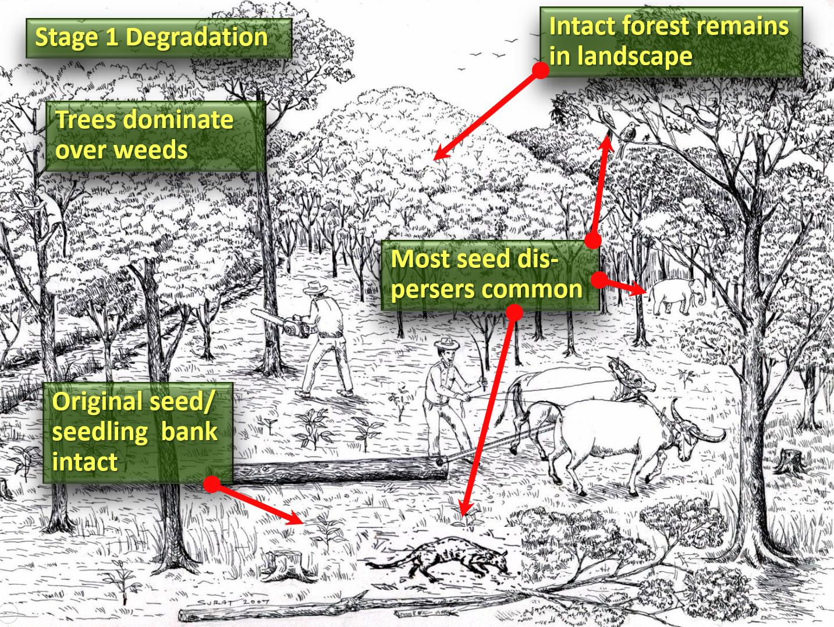

SITE CONDITIONS |  | LANDSCAPE CONDITIONS
VEGETATION | Trees dominate over herbaceous weeds | FOREST | Large remnants remain as seed sources
SOIL | Little localized disturbance; remains mostly fertile | SEED DISPERSERS | Common; both large and small species
SOURCES OF REGENERATION | Plentiful: soil seed bank viable; dense seedling bank; dense seed rain; live tree stumps | FIRE RISK | Low to medium
Recommended restoration strategy:
- Protection from encroachment, cattle, fire and any other further disturbances and prevention of hunting of seed dispersing animals
- Re-introduction of locally extirpated species
Options to increase economic benefits:
- Extractive reserves for sustainable use of forest products
- Ecotourism

Stage-2 Degradation

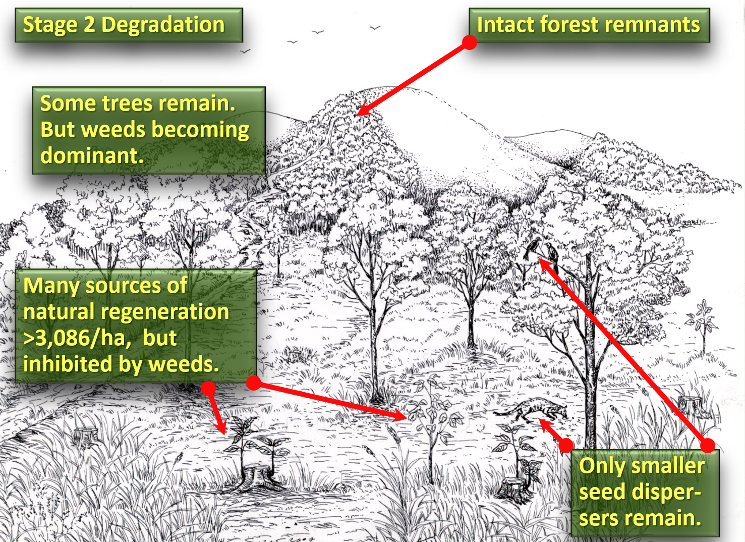

SITE CONDITIONS |  | LANDSCAPE CONDITIONS
VEGETATION | Mixed trees and herbaceous weeds | FOREST | Remnants remain as seed sources
SOIL | Remains mostly fertile; erosion low | SEED DISPERSERS | Large species becoming rare, but small species still common
SOURCES OF REGENERATION | Sufficiently dense to close canopy in 3 years but suppressed by weed growth | FIRE RISK | Medium to high
Recommended restoration strategy:
- Protection + accelerated natural regeneration (ANR)
- Re-introduction of locally extirpated species
Options to increase economic benefits:
- Enrichment planting with economic species lost through unsustainable use
- Establishment of extractive reserves to ensure sustainable use of forest products
- Ecotourism

Stage-3 Degradation

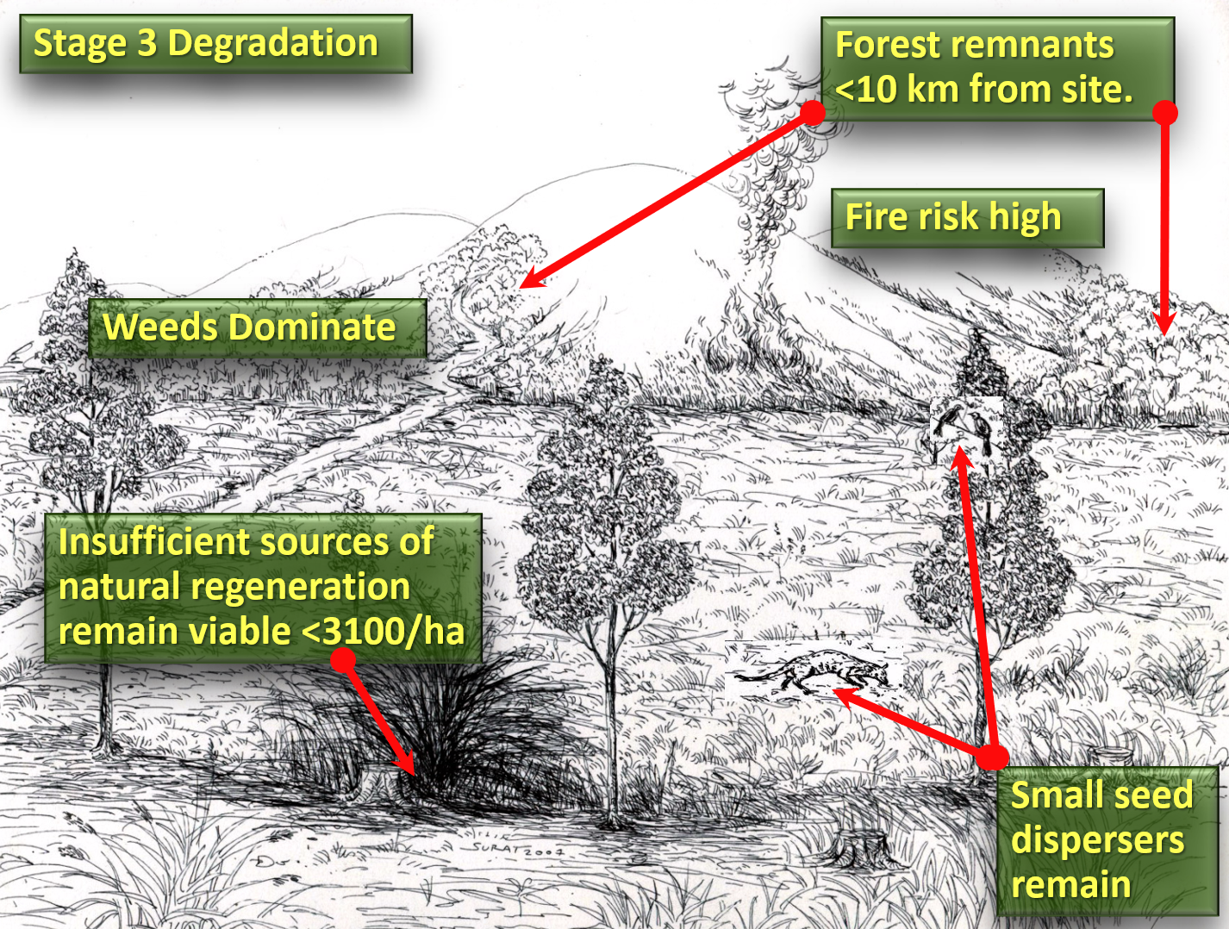

SITE CONDITIONS |  | LANDSCAPE CONDITIONS
VEGETATION | Herbaceous weeds dominate | FOREST | Remnants remain as seed sources
SOIL | Remains mostly fertile; erosion low | SEED DISPERSERS | Mostly small species dispersing small seeds
SOURCES OF REGENERATION | Mostly from incoming seed rain. Not dense enough to close canopy in 3 years | FIRE RISK | High
Recommended restoration strategy:
- Site protection + accelerated natural regeneration (ANR) + planting framework species

Options to increase economic benefits:
- Planting framework species that have economic benefits
- Ensuring local people benefit from funding of tree planting and site maintenance
- Analogue Forestry or “Rainforestation” farming

Stage-4 Degradation

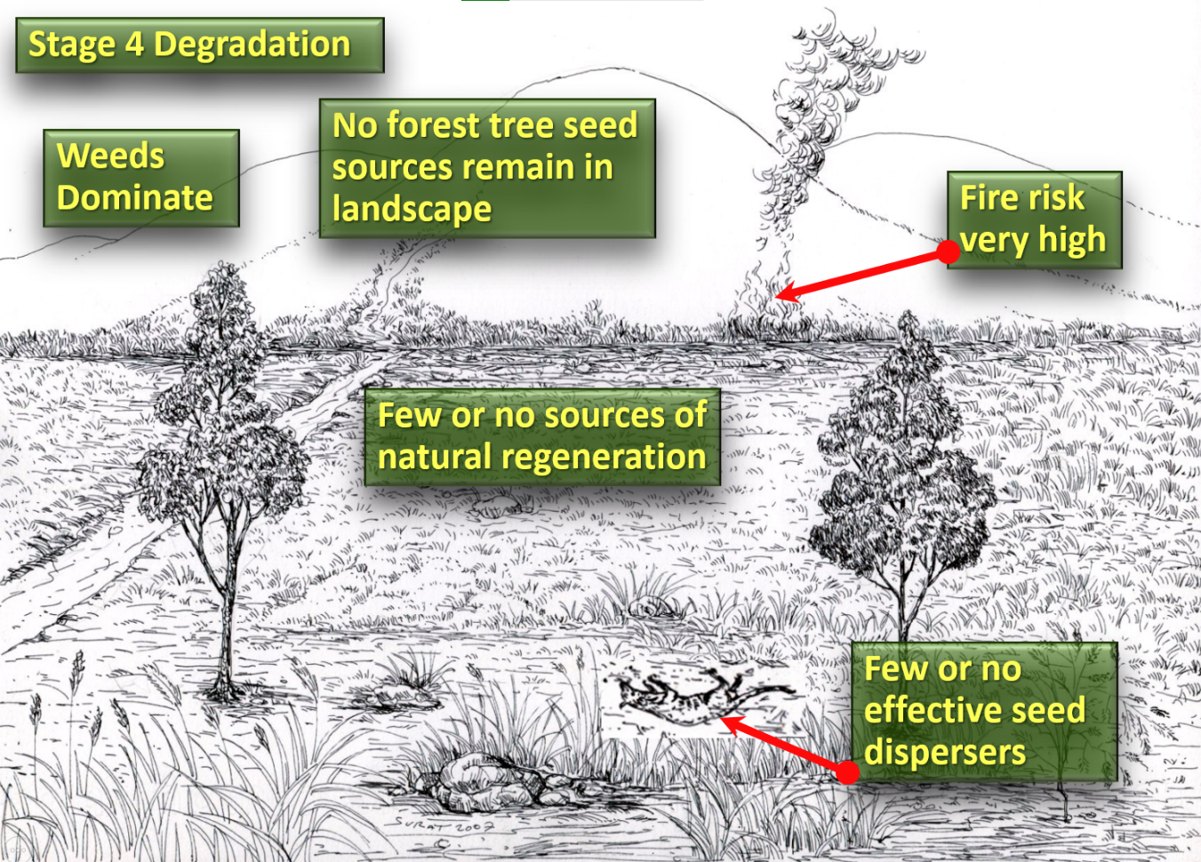

SITE CONDITIONS |  | LANDSCAPE CONDITIONS
VEGETATION | Herbaceous weeds dominate | FOREST | Remnants too few or too distant to disperse tree seeds to site
SOIL | Erosion risk increasing | SEED DISPERSERS | Mostly gone
SOURCES OF REGENERATION | Few | FIRE RISK | High

Recommended restoration strategy
- Site protection + accelerated natural regeneration (ANR) + planting framework species + enrichment planting with climax species
- Maximum diversity methods (Goosem and Tucker, 1995) e.g., Miyawaki method
Options to increase economic benefits:
- Enrichment planting with economic species + sustainable harvesting on non-timber forest products.
- Employment of local people on the restoration program
- Analogue forestry or “Rainforestation” farming

Stage-5 Degradation
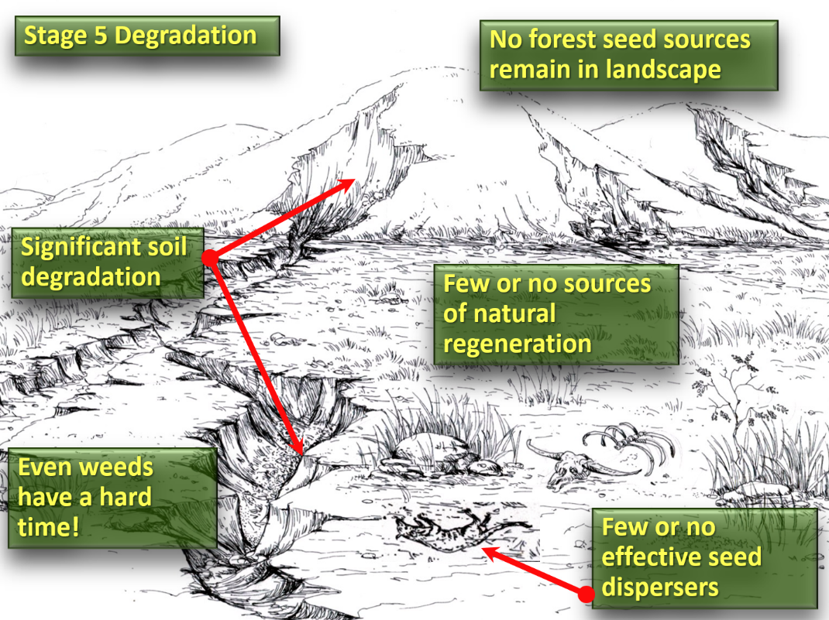

SITE CONDITIONS |  | LANDSCAPE CONDITIONS
VEGETATION | No tree cover. Poor soil may limit growth of herbaceous weeds. | FOREST | Usually absent within seed dispersal distances of site
SOIL | Poor soil conditions limit tree establishment | SEED DISPERSERS | Mostly gone
SOURCES OF REGENERATION | Very few or none | FIRE RISK | Initially low (soil conditions limit plant growth); higher as the vegetation recovers
Recommended restoration strategy:
- Soil improvement e.g., green mulch, compost/fertilizers and soil micro-organisms etc.…
- … followed by planting “nurse trees” – hardy nitrogen-fixing trees to further improve the soil (also known as “plantations as catalysts” … and then thinning of nurse trees and their gradual replacement by planting a wide range of native forest tree species
Options to increase economic benefits:
- There will be few economic benefits until the soil ecosystem is recovered
- Nurse-tree plantations of commercial tree species to generate revenue from thinning
- Mechanisms to ensure that local people benefit harvesting of commercial tree species
- Once the nurse tree crop is ready for thinning and modification, options for economic benefits are the same as for Stage-4

Stephen Elliott 28/05/23

en.wikipedia.org/wiki/Analog_forestry
www.rainforestation.ph/index.html

